

Business Report

Advance Financial Technology



710024722

Word Count - 1652

**Business Report**



**INDMoney**

**Introduction**

We've seen a surge in fintech activity in recent years, consumers are increasingly turning to alternative, digital methods of managing their finances, and both tech-savvy startups and traditional financial institutions (FIs) are entering the fintech industry. We will discuss about one of the super money app, Which is growing rapidly in India. In this report we go through their journey, discuss about their current state and will also analyze its future. We will also analyze market and state appropriate strategic recommendation for the future.

**About**

**Company overview**

**Name -** INDMoney

**Founded Year -** 2019

**Location** - Gurgaon, India

**Company Stage** - Series D

**Total Funding -** $159M

**Last Funding Round -** $11M, Series D, Mar 28, 2022

**Valuation -** $631M as on Jan 21, 2022

**Annual Revenue -** $3.13M as on Dec 31, 2020

**Employee Count -** 253 as on Sep 30, 2021

There have been many financial apps in the market. All of them serve different products and areas. E.g., Stock broking app, expense management, loan repayment, budgeting etc. These created a gap and hassle for investors or normal individual. These was considered as a gap and then it was filled with INDMoney. IndMoney started as a family super finance app and provided all kind of personal finance service. They started with US stocks as main attraction.

INDmoney is your one-stop SuperMoneyApp for all of your financial needs. The app automatically organizes your finances, assists you in goal setting, and uses machine learning to help you save and invest with no commissions.

INDmoney (previously known as INDwealth) was launched in 2019 with the goal of providing individuals and families with a better financial future. Finzoom Investment Advisors (p) Ltd, a SEBI-registered Investment Advisory entity, owns the brand. Tiger Global, Steadview Capital, and Dragoneer are among the investors in the company.

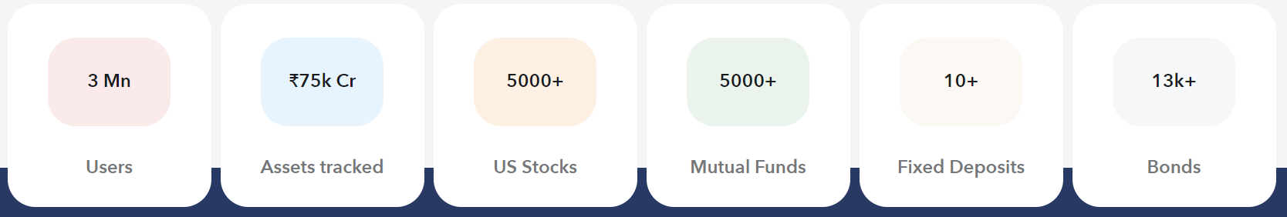

Image1: Current data of the company.

**Services:**

* Super saver account for US stocks with zero commission and best exchange rates.
* Automatically track all your money. Manage all your money across investments, loan, taxes and expense at one place.
* Zero commission mutual fund.
* Super stocks – basket of top stocks based on strategies.
* Investment calculators
* IPO center – 3 clicks IPO application.

**Premium Services**

* Advance reports across for all family members.
* Life and health insurance – Robo Driven
* Tax Planning
* AI based Investments.

**Finance: -**

Several new companies have entered the personal wealth management industry in recent years, including Paytm Money, Groww, and INDMoney (previously INDwealth). The category is still in its early stages, as evidenced by INDMoney's financials for fiscal year 2019-20.

The company generated Rs 1.07 crore in operating revenue in its second year of operation. The Gurugram-based firm's overall revenues increased by 2.3X to Rs 7.26 crore from Rs 3.17 crore in FY19.

Importantly, income from fixed deposits and mutual funds accounted for 85.4 percent of INDMoney's topline in FY20, totaling Rs 6.2 crore. Non-operating revenue climbed by 95.6 percent in FY19, from Rs 3.17 crore.

The majority of INDMoney's operating revenue comes from advising fees collected from premium users on the platform, as well as distribution fees earned from AMCs and mutual funds.

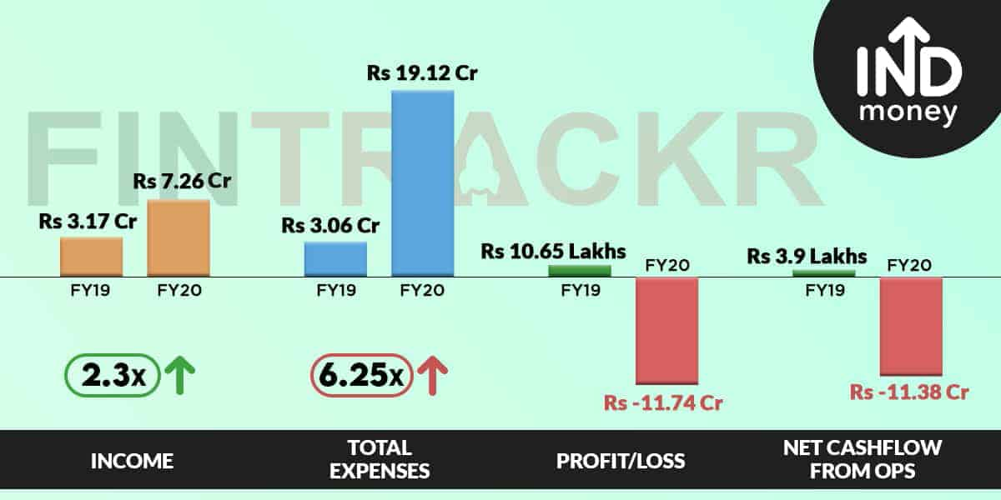

Image2: Financial data of the company for FY19 and FY20

**Disruption:**

IndMoney has basically disrupted all most all the areas of financial services. From banking to insurance and from Investments to expense management. It has created a one stop solution for all personal finance problems. In terms of technological disruptions, they are working amazingly in artificial intelligence and machine learning. They use cutting edge technologies for better and economical customer experience. Let’s discuss few examples of use cases.

Example:

1) The app tracks all your investments and insurances at one place. It let you know if you are paying any extra commission which can be surpassed. For mutual funds it lets you know if you are investing in regular mutual fund which usually takes commission and then in one click allows you to bypass the commission and turn it to direct mutual fund.

2) Robo advisory is an extra ordinary market disrupting use case of AI and machine learning. In this app it is used for automatic asset allocation as per market condition. Also, they have feature for smart goal creation and also expense management to reach your goal.

**Business Strategy:**

The 3 C’s

Corporation: -

Mission: - “To improve the financial lives of the people by helping them plan, save and earn more! “

Vision: - “To be the SuperBank for the Family”

IndMoney is working for better financial future of the families. They are working for better financial decision in the present that will improve the financial lives of the people. They mainly focus on Zero commission investments. Economical, quality and cutting-edge technologies are few key qualities of the company.

Customer:

They have well defined customer segment. All working segment is their prime target customer(22-45)s. As most of their services are free even newly earning individuals are also tapped by them. Their primary revenue model lies in premium services.

Competitors:

India is flooded with financial service application. Many big players are into this game such as Paytm money, stockal, zerodha and many other applications. Not any of its competitors are exactly doing each and every thing they have. If the quality of services is maintained they can easily be market leader and can also disrupt already existing tech products.

Benefit from technology

* Saves 50–70% on computing costs
* Automates scaling for massive growth
* Improves resiliency with isolated containers
* Analyzes user data to customize recommendations
* Enables dashboards for user insights and business intelligence

**Recommendations**

In India there is a wave of fintech start-ups. After the digital revolution there has been a huge scope of Fintech innovations to disrupt the existing financial services market. Threats are a integral part of business report as it creates a perspective of a business a whole. Let us discuss about the opportunities and treats for IndMoney.

**Opportunities:**

Account aggregator: -

Besides the financial information, collected additional net-worth of the borrower such as property valuations, debt liabilities, and cash inflows and outflows may be brought together by financial advisors on behalf of their clients. The borrower can also avail services such as access to loans and access to money management if their banks join the AA network of data sharing. INDMoney has already been having most of the financial information of the users so it can easily come up with feature.

Personalized loans: -

As we have discussed an opportunity as account aggregator, Personalized loans are extension to this feature. With all the required data and amazing technology one tap loans personal loans can be an amazing feature to look about in near future.

BNPL: -

In the time of instant credit, BNPL is another service to look into. BNPL stands for buy now pay later. This is being used by many retailers and ecommerce websites to create a difference in sale. In the times of growing service sector in India, there will be rise in salaried population and this will me the main target audience for this feature.

Crypto trading: -

There is whole new wave of cryptocurrency craze in the market. Web 3.0 has gained massive interest all around the globe. There have been many use cases developed all around this. There is a huge scope in this sector. Legalities are still not clear in India but soon will be clear and can be a huge opportunity for the company.

Now with the opportunities and rapidly changing technological innovations there will always be scope of threats that are to be kept in mind.

Threats:

Digital/privacy and integrity challenges: As the world grows with innovative technologies there will always be scope of system breakdown. We have already seen many dark web leaks recently. Information and private data need to be well handled and protected.

Competitors: - Fintech is a competitive sector especially in a fast-growing economy like India. There are many big players already in the game of finance. Indian youth is tech savvy and keeping up with huge competitors which have a huge capital can be quite stressful.

Sustainable Scaling: IndMoney has started its operation just 2-3 years back. They have been scaling up at very aggressive rate. As a start up they scaling up at this aggressive rate is quite risky. Making a business sustainable is what every company aims for. maintaining all the features in relatively new field is quite a task which if not being executed correctly can be make a business go bankrupt.

Profitability: In new age technology startups massive cash burns is a common phenomenon for acquiring customers. IndMoney being a super app has lot of features in it. Which in turn require a huge capital as most of the services are offered free. Main revenue of the company should come from premium paid services but it comes from mutual fund and Fixed deposits, so they require to turn the tables to become profitable.

**Conclusion:**

India being the fastest growing economy and as per IMF it will continue to be so for the next few years. Taking that into account GDP per capita would increase and people will have more disposable money which will result in more investments. India’s wealth management sector is well underpenetrated than most of its counterpart. Taking this into account INDMoney has a bright and rewardable future. highlighting on the opportunities and threat we can see account aggregator license will help INDMoney to set up more feasible and attractive offer for personal loans. BNPL has just started to take off so it is not clear about its scalability. These opportunities can turn to be a great revenue source if it is implemented and executed correctly. Threats are more of a common for fintech start ups which are Privacy, integrity of data, competitors and profitability. Sustainable scaling is also very important for a startup that is scaling at such massive rate. Founder being more experienced entrepreneur gives us positive hopes for sustainable scaling. Overall sustainable scaling, monetizing, customer acquisition and customer satisfaction needs to be primary focus. Treats need to be kept under control. These would lead to better possibility of successful business.

**References**

* Tyagi, G. (2020, December 3). *INDMoney spent Rs 19 Cr to earn Rs 1.07 Cr in operating revenue in FY20*. Entrackr. <https://entrackr.com/2020/12/indmoney-spent-rs-19-cr-to-earn-rs-1-07-cr-in-operating-revenue-in-fy20/>
* *Best Platform to Track & Manage All Your Investments & Loans | INDmoney*. (n.d.). Www.indmoney.com. Retrieved April 28, 2022, from <https://www.indmoney.com>
* *The 3 Cs of Brand Development: Customer, Company, and Competitors*. (n.d.). MaRS Startup Toolkit. Retrieved April 28, 2022, from <https://learn.marsdd.com/article/the-3-cs-of-brand-development-customer-company-and-competitors/#:~:text=the%20U.K.%20market.->
* *INDmoney Case Study*. (n.d.). Amazon Web Services, Inc. Retrieved April 28, 2022, from <https://aws.amazon.com/solutions/case-studies/indmoney/>
* How account aggregators can bring an era of democratised credit. (n.d.). *The Economic Times*. Retrieved April 28, 2022, from <https://economictimes.indiatimes.com/small-biz/money/how-account-aggregators-can-bring-an-era-of-democratised-credit/articleshow/87577782.cms?from=mdr>
* *INDmoney Company Profile: Valuation & Investors | PitchBook*. (n.d.). Pitchbook.com. Retrieved April 28, 2022, from <https://pitchbook.com/profiles/company/234208-09>